When logged into Gradintelligence you are able to share your HEAR securely with whoever you wish, whether this be employers, employment agencies, other universities or government agencies, by sending them an electronic token.
Log into Gradintelligence (www.gradintel.com)
From the Dashboard, you will be able to select the options to both View and Share your HEAR.
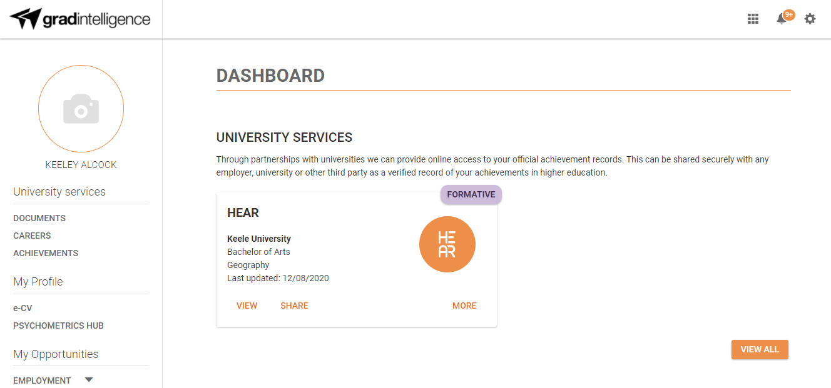

To share your HEAR, click Share on the dashboard, and complete the fields shown below to send an electronic token to allow you to share your HEAR
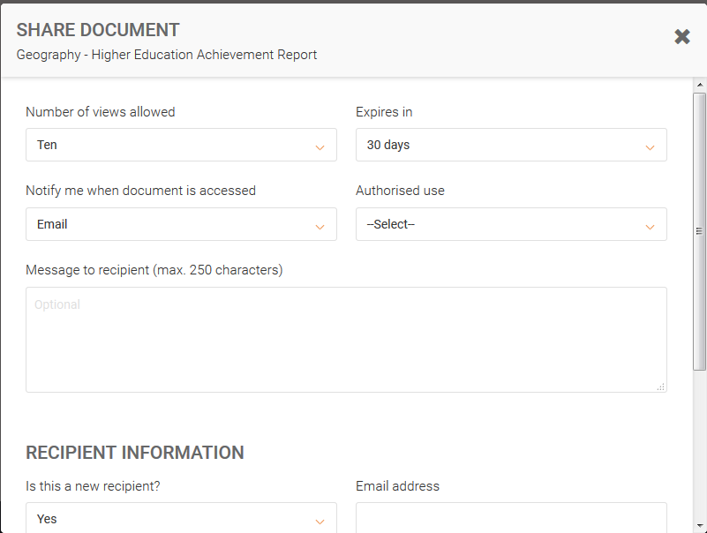
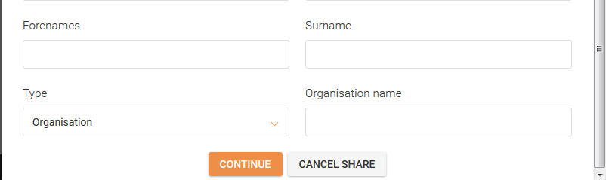
You can view Share History by selecting the More tab on the Dashboard.

